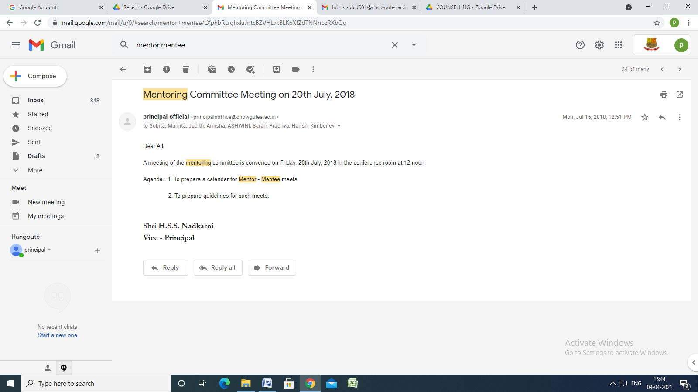

Mentoring Committee Meeting on 20th July, 2018
principal official <principalsoffice@chowgules.ac.in> | Mon, Jul 16, 2018, 12:51 PM
to Sobita, Manjita, Judith, Amisha, ASHWINI, Sarah, Pradnya, Harish, Kimberley

Dear All,

A meeting of the mentoring committee is convened on Friday, 20th July, 2018 in the conference room at 12 noon.

Agenda : 1. To prepare a calendar for Mentor - Mentee meets.

2. To prepare guidelines for such meets.

Shri H.S.S. Nadkarni
Vice - Principal

